How to Edit the Home and Cities Page Templates
Homepage Sections:
I added the new Leave No Trace section to the home page via custom code here. No other way to do it as the home page uses its own custom-coded template: https://ramblersutah.com/wp-admin/theme-editor.php?file=templates%2Ftpl-home.php&theme=ramblers-theme
If you want to make a change to the section background image or the image centered in the section, you have to copy and paste the URL of the image you want to use into place where highlighted in yellow below:
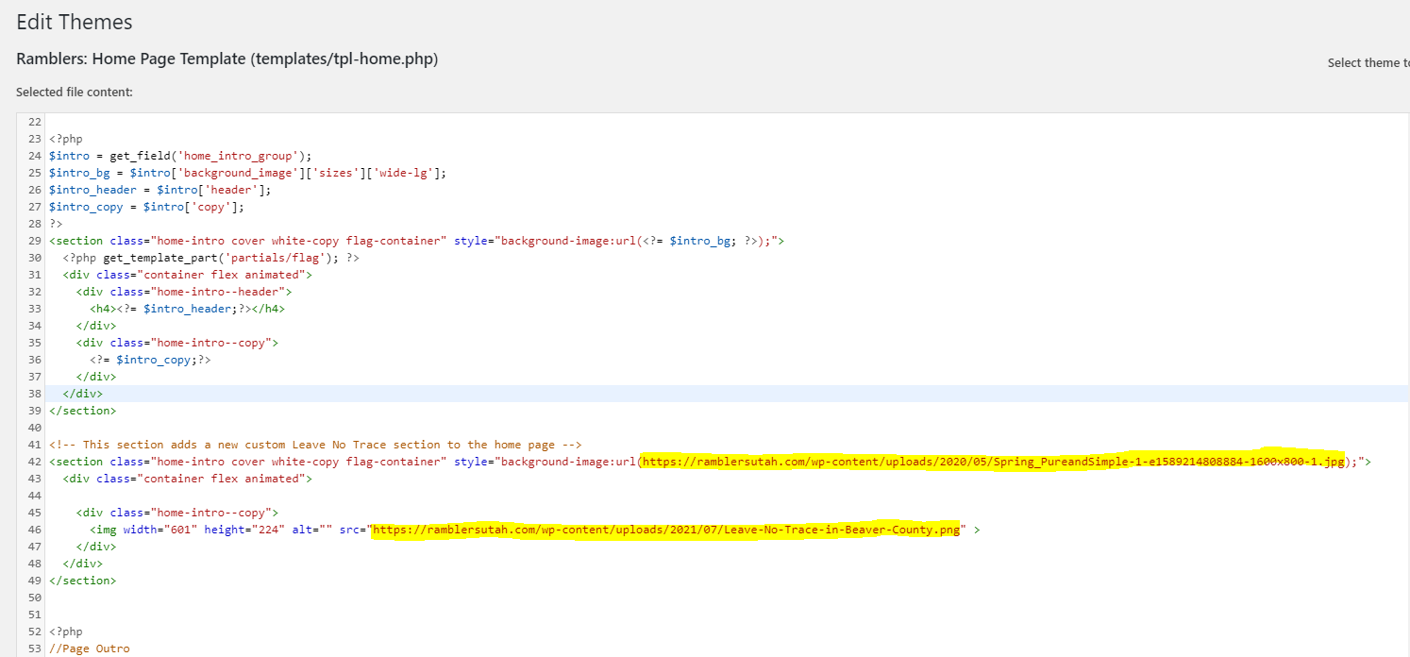

Cities Page Sections:
I added code to the Cities template to display a new Leave No Trace section.
As with the Home Page template you can change the images here:
https://ramblersutah.com/wp-admin/theme-editor.php?file=templates%2Ftpl-cities.php&theme=ramblers-theme
